CNS 1410 Object-oriented Programming

Programming Project 1: Building a string tokenizer

Due Date:
Must be submitted no later than 1:00am next Monday.
Programs received prior to 1:00am on Sunday will receive 5 bonus points, only if program completely meets the specifications and executes correctly.

Objective:
At the completion of this project, you will have created an application that
- defines a class that can tokenize a string, using character arrays and pointers,
- gets input from the user,
- creates a tokenizer object, and
- prints out the tokens in the input string.

Project
Tokenizing a string breaks the string up into individual pieces, that are separated by some delimiter character in the string. For example, the sentence "I Love New York!" would produce the following tokens, if a blank space were used as the delimiter:
I
Love
New
York!
In this project you will define a StringTokenizer class and use it to tokenize a string of words input by the user.

The StringTokenizer Class
The StringTokenizer class will contain at least the following data members:
- A character pointer, initially pointing to the string to be tokenized. Note that you may not use the string class to solve this problem!
- The delimiter character
and the following member functions:
- A parameterized constructor that takes the string to be tokenized and the delimiter character as parameters The string passed to the constructor must be null terminated.
- The next( ) function. When called, this function returns a pointer to the next token in the string, or a null pointer if there are no more tokens. As a side effect, any delimiter characters in the original string are replaced with the null terminating character. Note that the next( ) function does not print out the token, it simply returns a pointer to it. You may not use the string class or the strtok( ) function in this assignment.
Be sure that your next( ) function takes no parameters and returns a char*.

The Program
Write a driver program that gets a string of words from the user. Then create a StringTokenizer object, passing the user input string as a parameter, and a blank space as the delimiter character. Your program should print each token in the string on a separate line. Make sure that the DOS window stays open so that the grader can see your output. The following code shows you an example of how your string tokenizer class can be used.
StringTokenizer parser("I Love New York!", ' '); // create a StringTokenizer object
char *token; // declare a char pointer to hold the address returned by next( )
token = parser.next(); // get address of the first token
while (token != NULL) // keep getting tokens until a NULL is returned
{
cout << token << endl;
token = parser.next();
}
Your tokenizer should be able to handle literal character strings, as in the example above. This requires that you make a copy of the character array, since literals are immutable. It should also handle any delimiter, so don't hard code in the space as the delimeter character.
Format and document your code in accordance with the course style guidelines. Include a file prologue identifying you as the author. Submit your project using the instructions outlined in the Course Syllabus, Programming Projects section.

File(s) to Submit:
  - driver.cpp
  - tokenizer.h
  - tokenizer.cpp
  - driver.exe

Hints
If you need some help on this project, there are some hints here.

Grading
The grade sheet for this project is here

Sample Output:
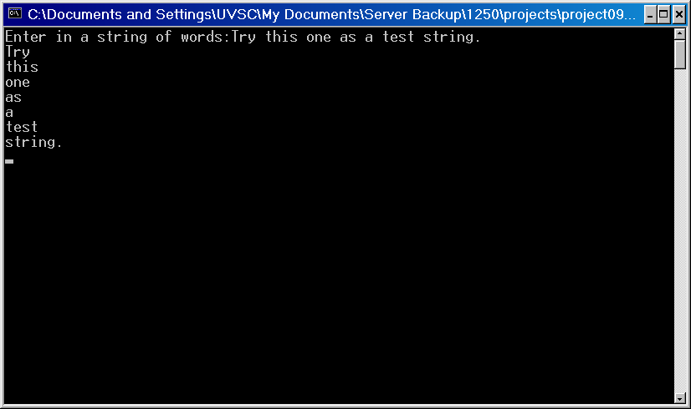
You can get an executable that runs correctly here!

